Online Shopping

# *SRS Document*

**Purpose of project**

This document is meant to delineate the features of Online Shopping, so as to serve as a guide to the developers on one hand and a software validation document for the prospective client on the other. The Online Shopping for electronics item shop web application is intended to provide complete solutions for vendors as well as customers through a single get way using the internet. It will enable vendors to setup online shops, customer to browse through the shop and purchase them online without having to visit the shop physically. The administration module will enable a system administrator to approve and reject requests for new shops and maintain various lists of shop category

**Scope of Project:**

Home delivery of fast via phone call is popular. The process seems easy to use but at times there is miscommunication sometimes. The main drawback of placing order via phone call is that there is no visual menu shown, the employees have to repeat a lot of things again and again to the customers. It’s a time consuming process which at times irritates customers. It would be much more comfortable for the customers to have an online shopping system. It would be hassle free for users as they can select the item they want and make payment for it. Also it will reduce the purchasing time for customers. Let us look at another benefit of using this system. Suppose I go to a fast item point and make order. Even after ordering fast item from their outlet, I have to wait at least 15 minutes for my order to be ready. Wouldn’t it be much more convenient if I ordered my fast item before using an online system and then it will tell me the time by which I have to pick my order from their counter!! It would be great for me as I don’t need to wait for my order. I need to reach there only when my order is ready. In a nutshell, we can say that improved and efficient services are provided to the customers by the inclusion of internet in your business. As a business point of view it gives you an edge over your competitors

Functional requirement

Admin requirements:

1)Admin can add items details like name ,photo , description / ingredients , price , category ………….etc.

1. Admin can view , edit the items details as well as enable/disable items according to season or availability .
2. Admin can track live orders and status update for particular delivery .
3. Admin can view previous transaction by date search and total amount at end .
4. Admin can view the users details which are given during registration

*User requirements:*

1)User must be log in with their credentials to access items ordering system .

1. User must be register with essential details for items ordering system

.

1. User can view different the items with respective categories "the menu list are viewable to user " .
2. User can view the item details and buy the product by doing payment .
3. User can view their cart details , delete items from cart , update quantity…..etc

.6) User can keep track of their orders with delivery status

Various functional modules can be implemented by the system. it provides a requirement overview of the system

**Description:**

* **Master Maintenance:-**

Is the system that maintains the detail of the products and their hierarchy attributes (size, weight, cost etc) The two main components of master maintenance are as follows.

* **Product master:-**

It’s include the information of the products, item no, size, categories etc. it’s is also the admin of vendor or seller where they can put the information of the products in websites.

* **Price master:-**

Only for the price of the products and applicable discount of the products

* **Transection:-**

Transaction is a payment method in which the transfer of money of buying products. This process is secure and password protected. Three steps involved in the online transaction are Registration, Placing an order, and, Payment.

* **Reporting:-**

After ordering for the product, the system will sent one copy of the bill to the customer’s Email-address and another one for the system data base.

* **Stock Report:-**

Produce the quantity of the products available and status of the products.

* **Order Report:-**

List of the products that can be buy by the customer. Who can bought?

* **Delivery Report:-**

List of the products that can be delivered to the customer.

* **Registration:-**

Customer wants to buy the product then he/she must be registered, unregistered user can’t go to the shopping cart.

* **Login:-**

Customer logins to the system by entering valid user id and password for the shopping.

* **Changes to Cart**:-

Changes to cart means the customer after login or registration can make order or cancel order of the product from the shopping cart.

* **Payment:-**

In this system we are dealing the mode of payment by Cash. We will extend this to credit card, debit card etc. in the future.

* **Logout:-**

After ordering or surfing for the product customer has to logout

*Non-function requirement:*

1)the application must be easy to use .

1.1) the language written in the application should remain simple and easy to understand by the public

1.2 )every items have photo in the application .

1. the application must be easy to maintaint both the system as well as the data base .
   1. )The item names should be clear and meaningful in both the database and the system.
   2. The system should have a use-case diagram, an activity diagram, a class diagram.
   3. The system should have database specification (ERD, tables) It Can process credit card payment.
   4. The system should be able to access credit card payments, visa, master card, e-wallet and pay Pal.
   5. The system should send a notification to the user indicating the payment success

***Use-Case Diagram(s)***

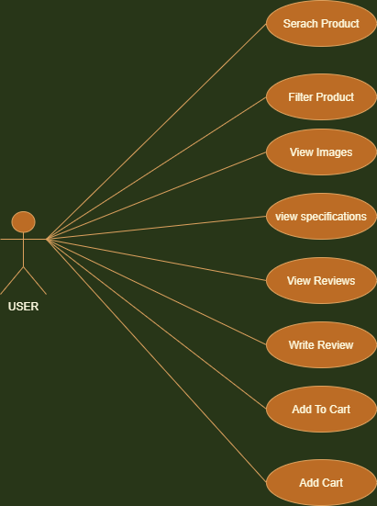*Activity Diagram(s)*

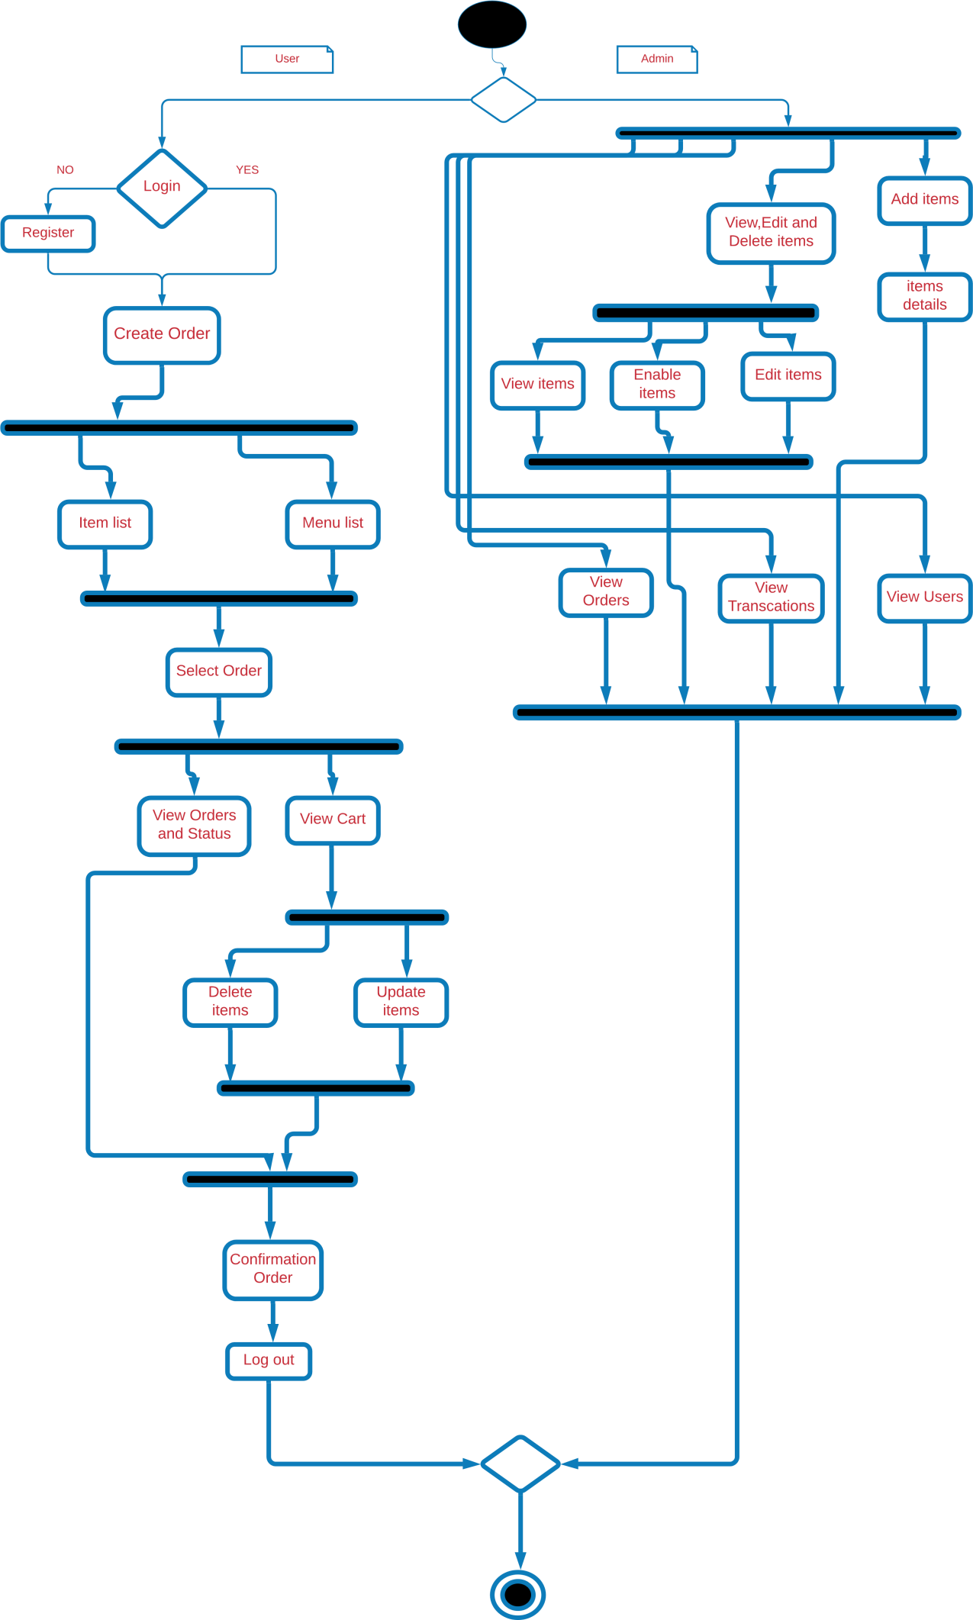

***Collaboration/Communication Diagram(s):***

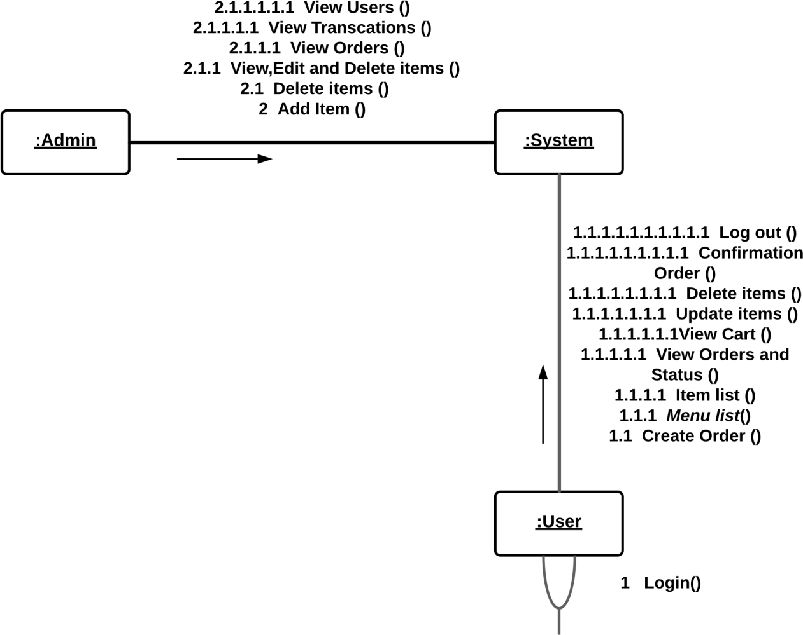

***Sequence Diagram(s)***

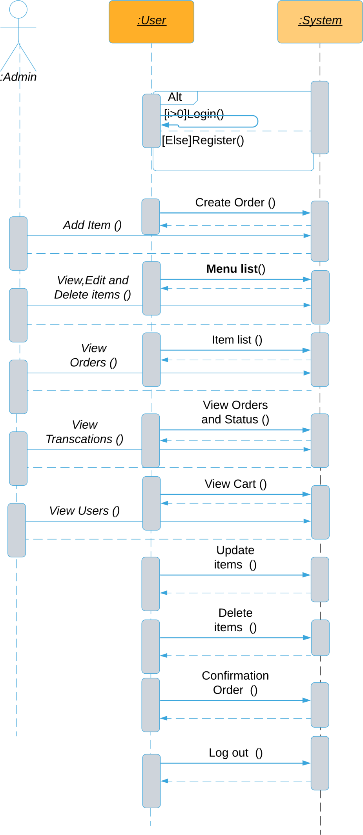

Data Flow Diagram

Context level diagram



First level DFD

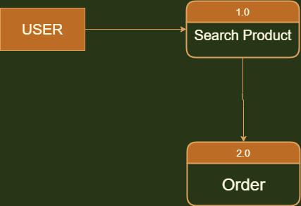

Second Level DFD

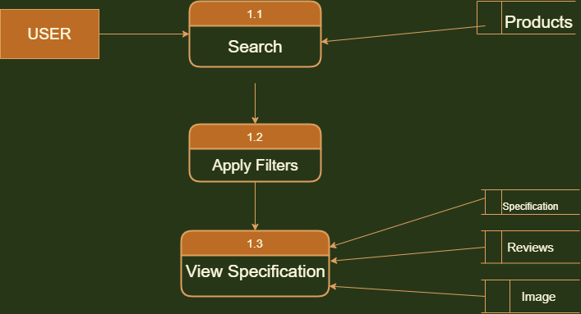

Second Level DFD

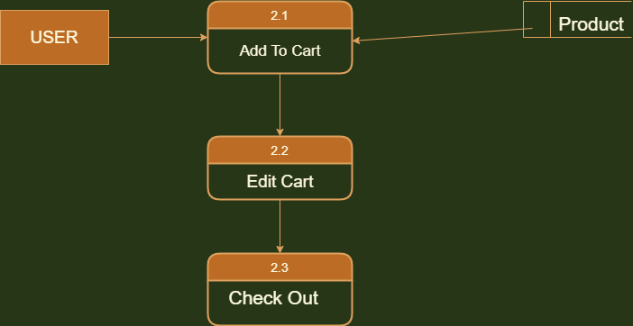

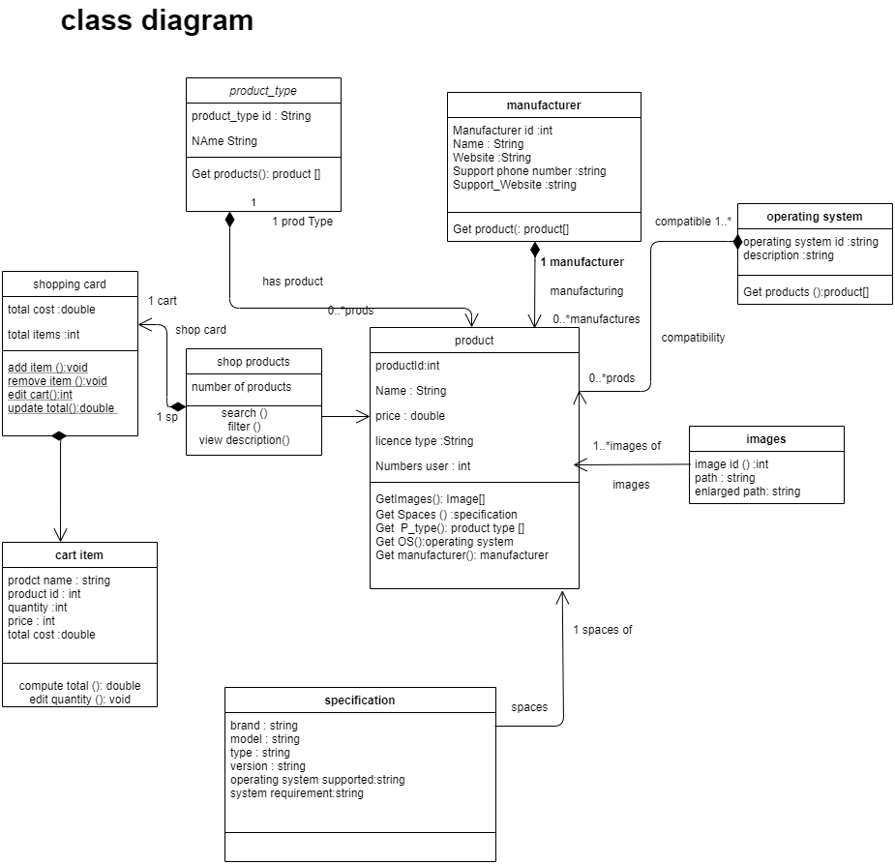

**Architectural**

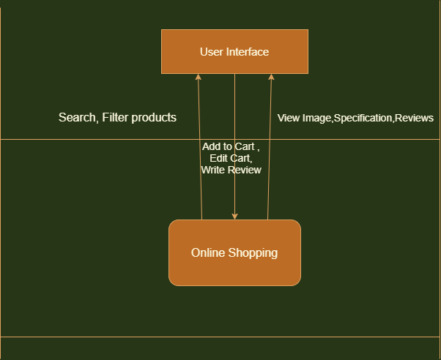

***Database Specification*** *(ERD, Tables):*

*ERD*

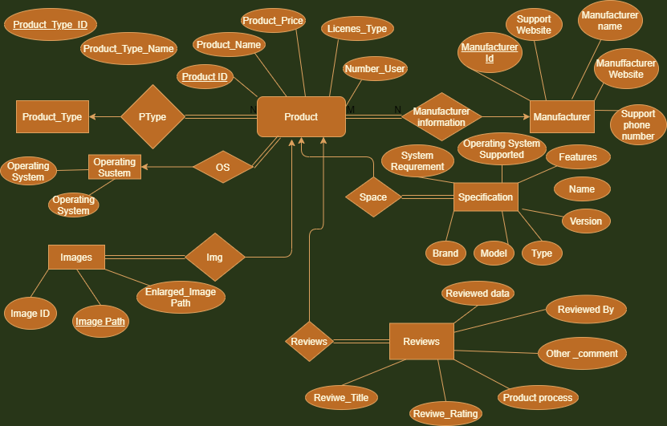

*Tables*:

